Chapter 6 Classification
extra worksheet 2: Shark key
Science understanding Verbal/Linguistic Visual/Spatial
Name: Class: Date:
1 Sharks have some distinctive features that can be used to identify them, as shown in the diagram below.
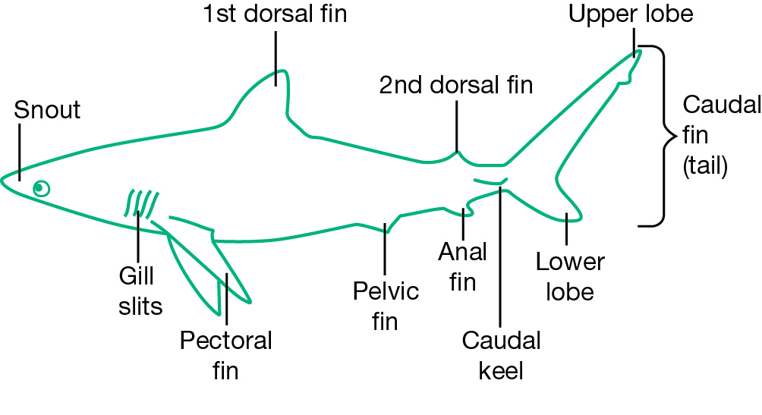
Use the key below to identify some of the sharks found in the seas around Australia.
1a | Anal fin present | 2
b | Anal fin not present | Dogfish
2a | Caudal keel present | 3
b | Caudal keel not present | 4
3a | Crescent shaped caudal fin (tail) | Mackerel shark
b | Long upper lobe to caudal fin (tail) | Tiger shark
4a | Head hammer shaped | Hammerhead shark
b | Head not hammer shaped | 5
5a | Extremely long upper lobe on caudal fin | Thresher shark
b | Upper lobe of caudal fin not extremely long | 6
6a | Cone shaped snout | Grey nurse shark
b | Broad rounded snout | Bronze whaler shark


